QUERY 1: What is the Distribution of Operating Systems Used by Users?
The data file “user-session.csv” contains a column of data for “platformType”. This column is ‘enumerated’ (or ‘enum’ for short) with five values: windows, mac, android, ios, linux. We want to know what the relative distribution of these operating systems is for our dataset.
To do this, we begin by running Splunk and accessing the list of Data Sources. First, access the Searching and Reporting interface. Click the Data Summary button. When the Data Summary panel opens, select the "Sources" tab and click the link for the “user-session.csv” file. This will load the data into Splunk and prepare it for searching. The command we will use is the “count by” command, as follows:

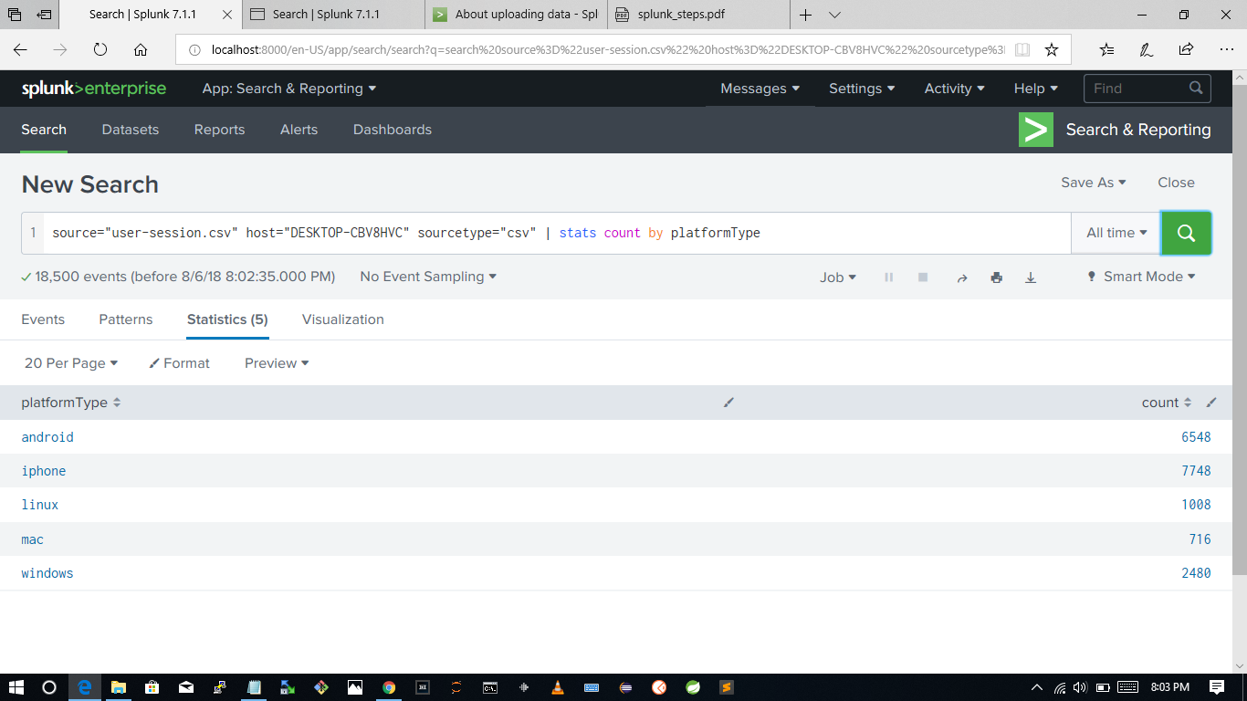
source="usersession.csv" | stats count by platformType

Creating a Chart in Splunk
To generate a chart of the above results, you simply click the “Visualization” tab and select the type of chart you want from the Type menu.

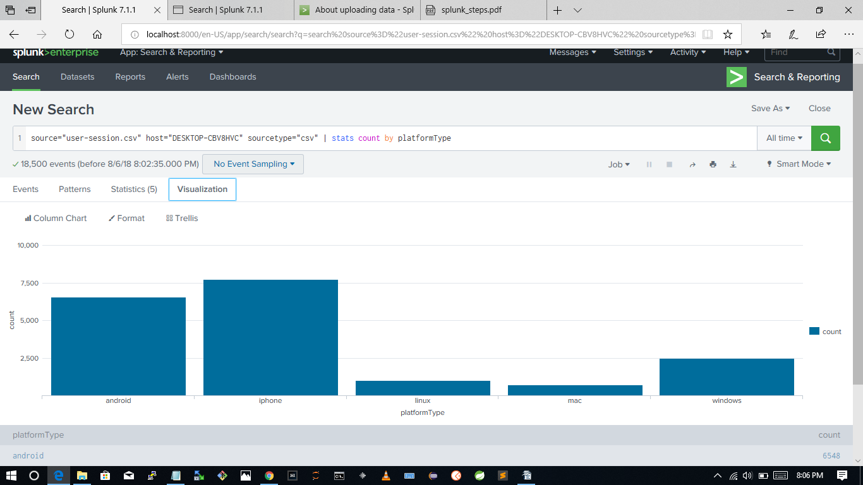

QUERY 2: What are the two most Commonly-Clicked Ads?
A similar query may be performed in order to determine the ads which are clicked most frequently. The file “ad-clicks.csv” contains data on what users clicked what ads.
To begin, in the Data Sources panel, select “ad-clicks.csv”.
In the Search box, enter the following Splunk query:
1
source=“ad-clicks.csv” | stats count by adCategory | sort 2 -num(count)
before

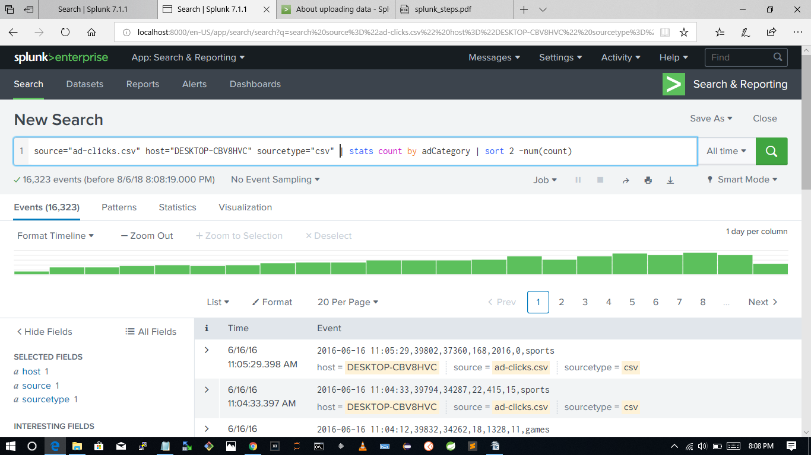

after

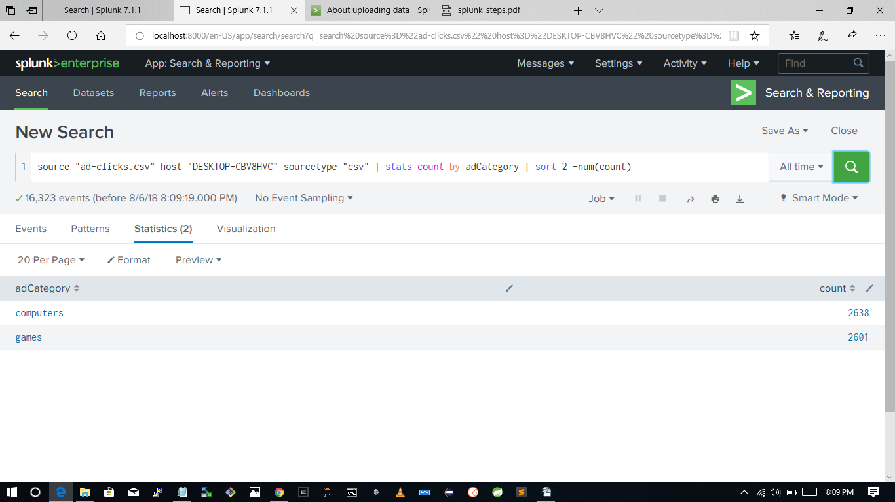

QUERY 3: What are the two most Commonly-Purchased Products?
The file “buy-clicks.csv” contains data on which users purchased which products on which dates. We can perform yet another similar search query in Splunk to determine which products are purchased most frequently.
To begin, in the Data Sources panel, select “buy-clicks.csv”.
In the Search box, enter the following Splunk query:

source="buy-clicks.csv" | stats count by buyId | sort 2 -num(count)

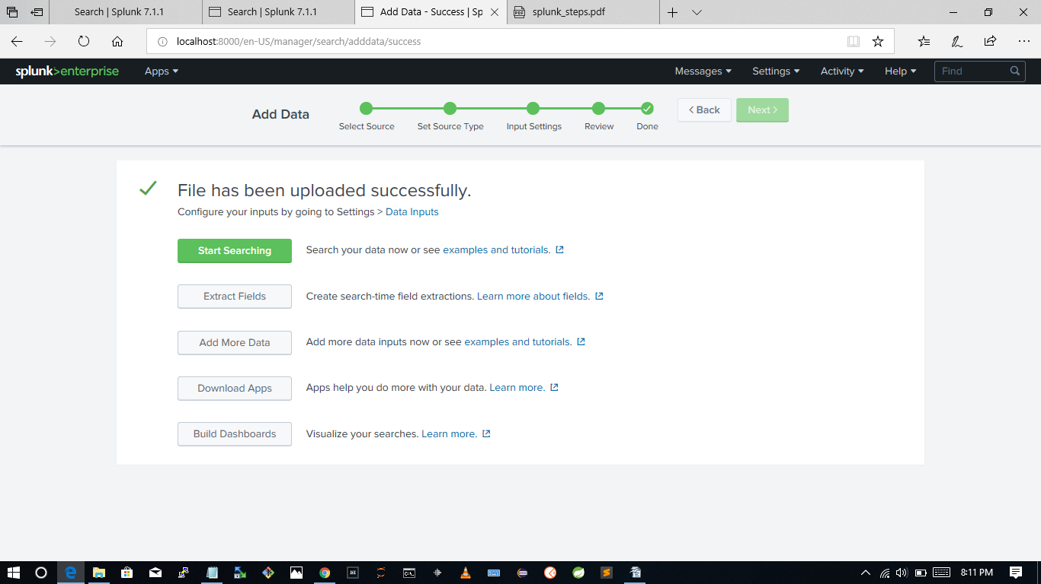

before
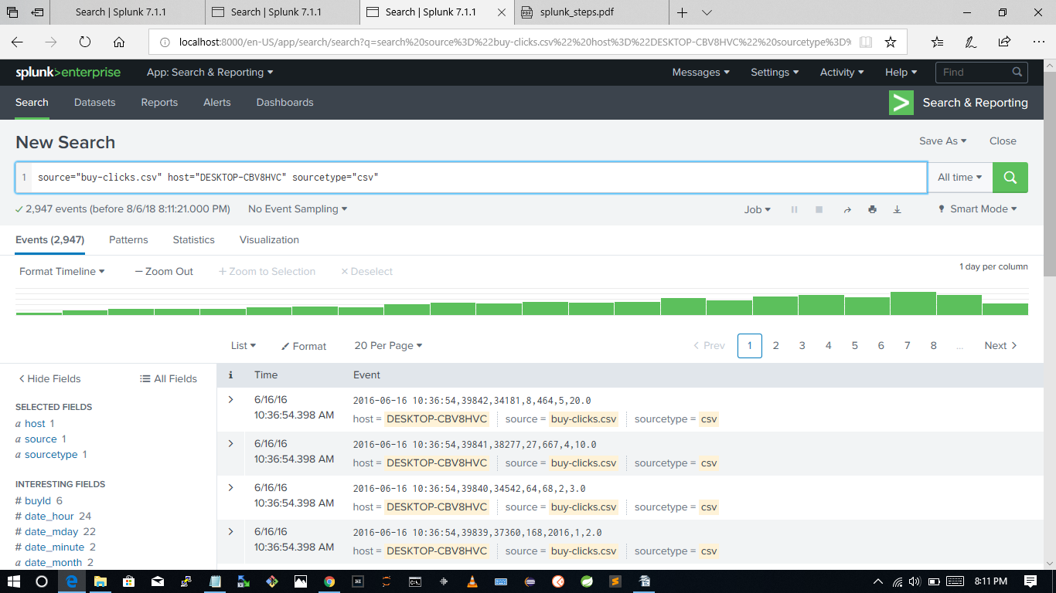
after

source="buy-clicks.csv" host="DESKTOP-CBV8HVC" sourcetype="csv" | stats count by buyId | sort 2 -num(count)

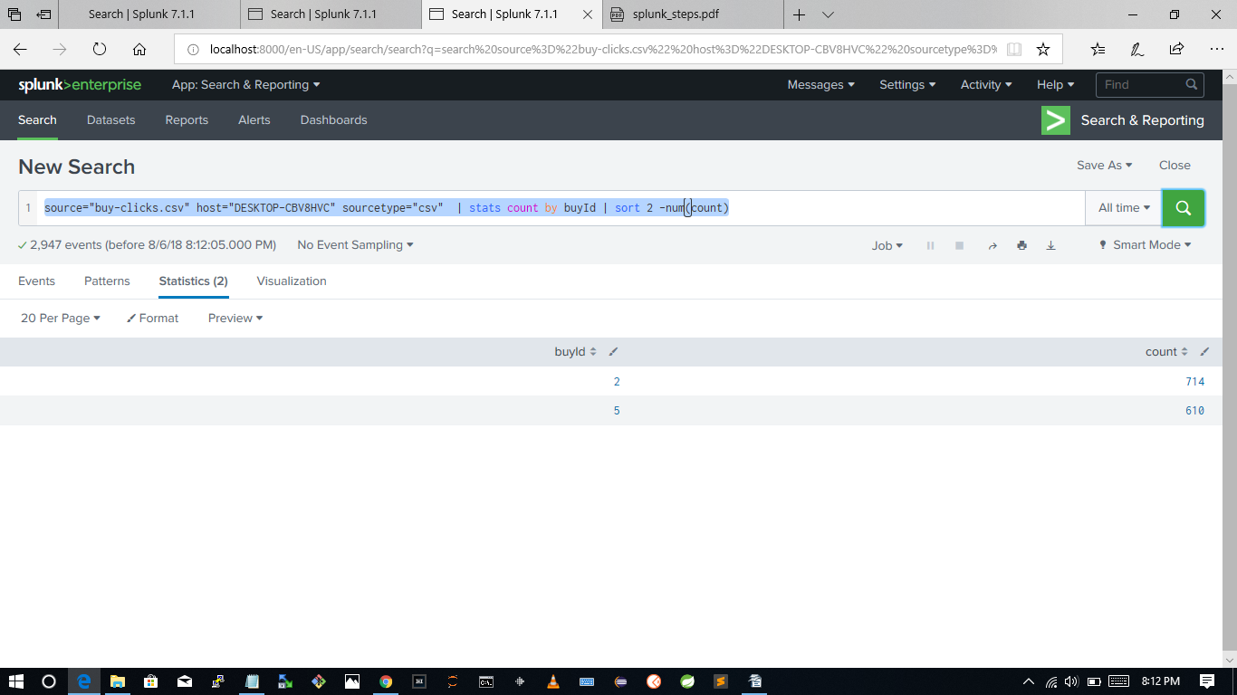

QUERY 4: What is the Average Team Size?
To calculate the average team size requires a somewhat more complex query. The “team-assignments.csv” file contains data on which users are part of which teams.
Our first step is to select the “team-assignments.csv” data file from the Data Sources. Next, we need to generate a distribution of team sizes using the same “count by” command we used in the previous step. Once we have that distribution, we need to calculate the average.
Here is the final query:
1
source="team-assignments.csv" | stats count by team | stats avg(count)
source="team-assignments.csv" | stats count by team | stats avg(count)

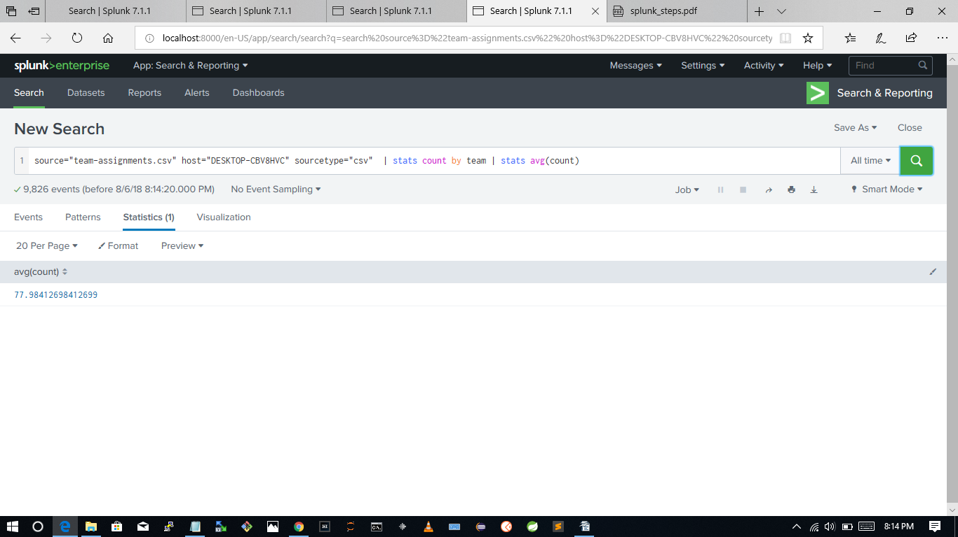

The ad-click events are listed in the file ad-clicks.csv. Each advertisement that is clicked on by a user generates $0.50 of revenue. What is the total amount of revenue generated by the ad-click events?
8162
5478
112
6844
None of the above
16323*.5 =8161.5

source="ad-clicks.csv" host="DESKTOP-CBV8HVC" sourcetype="csv" | stats count
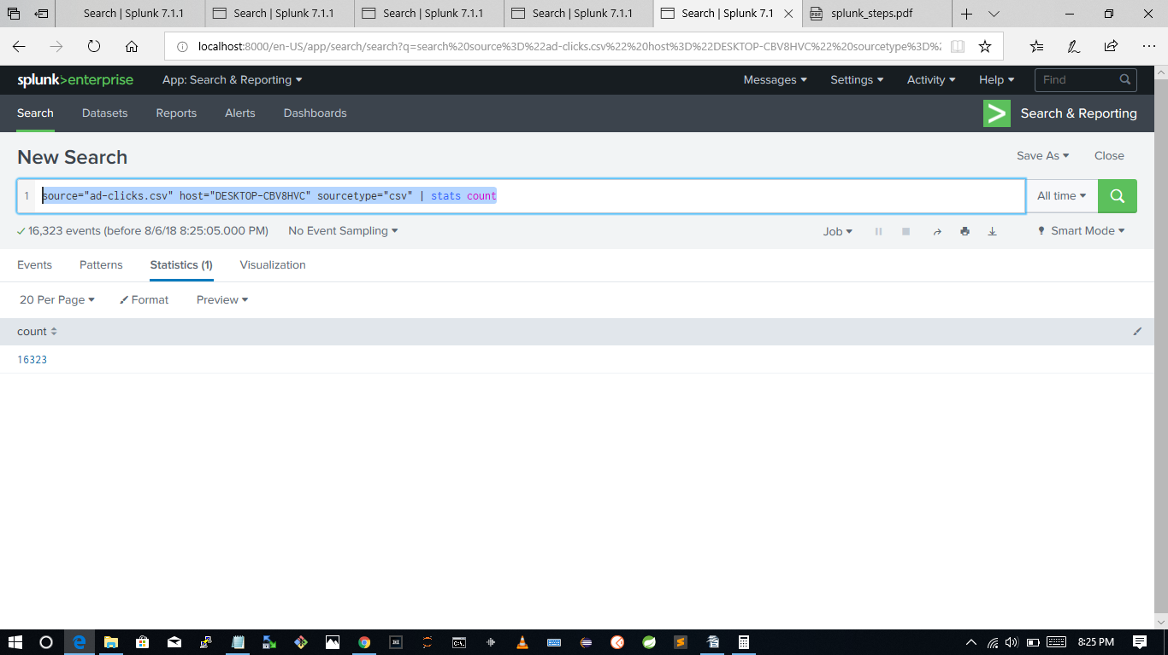
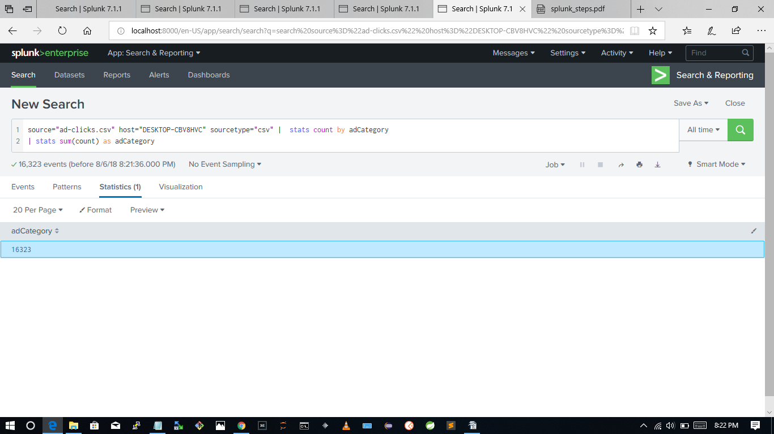

How many different categories of advertisements are there?
9
8
7
6

check statistics (9)
total events 16,323 – total count of ad clicks
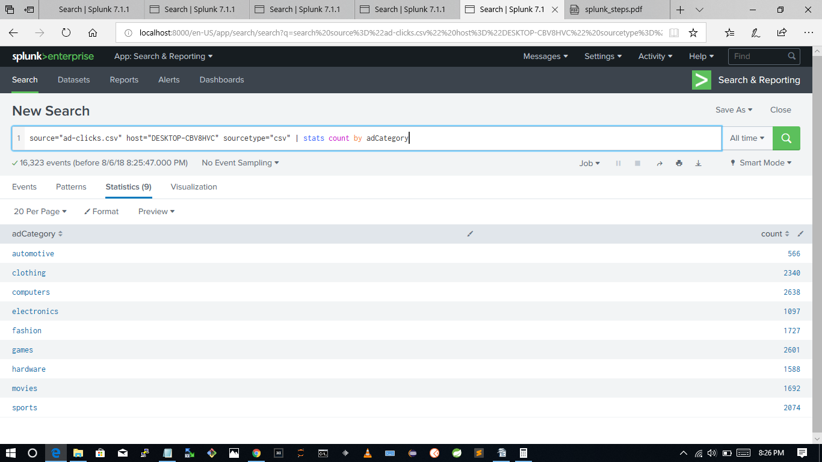

Let’s say electronics generates $0.75, and the other types of advertisements generate $0.40. What is the total amount of revenue?
6487
3
4009
6913
1097*.75 + (16,323 -1097) *.40 =
822.75 + 6090.4 = 6913.15

The file buy-clicks.csv lists the in-app purchases and the price of each purchase. When a user purchases an item, the company gets 2% of the price. How much revenue does the company make from the purchases in buy-clicks.csv?
428
284
824

source="buy-clicks.csv" host="DESKTOP-CBV8HVC" sourcetype="csv" | stats sum(price)

21427 *.02 = 428.14

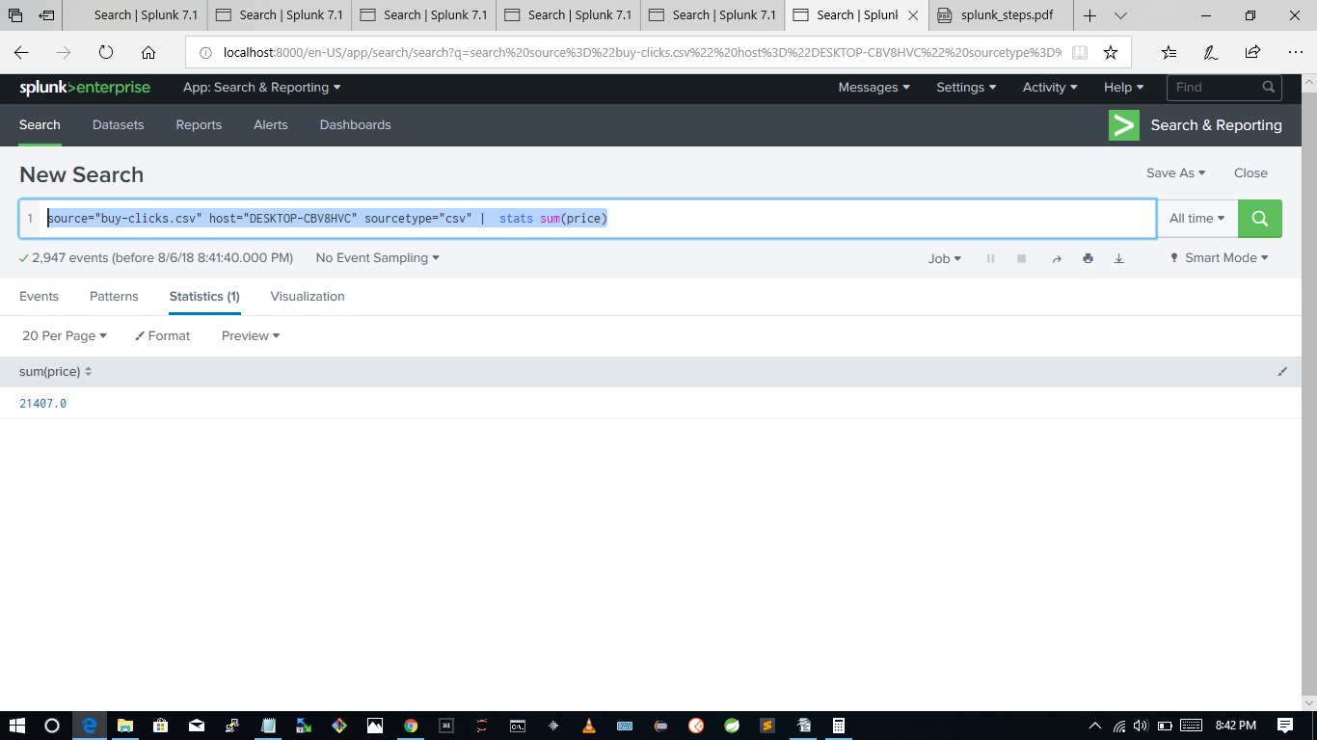
How many distinct items can be purchased?
6
5
4
3
source="buy-clicks.csv" host="DESKTOP-CBV8HVC" sourcetype="csv" | stats count by buyId

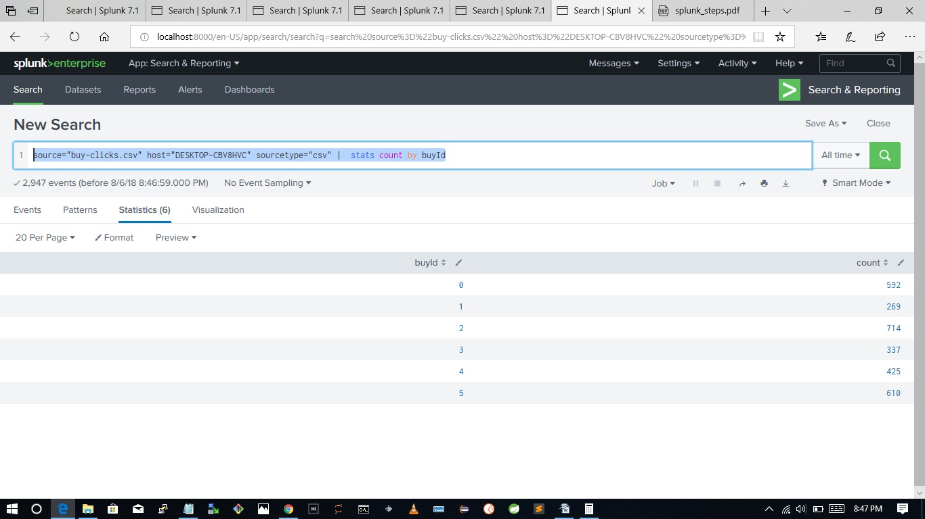

How much does the most expensive item cost?
20
40
60
80

source="buy-clicks.csv" host="DESKTOP-CBV8HVC" sourcetype="csv" | stats max(price)
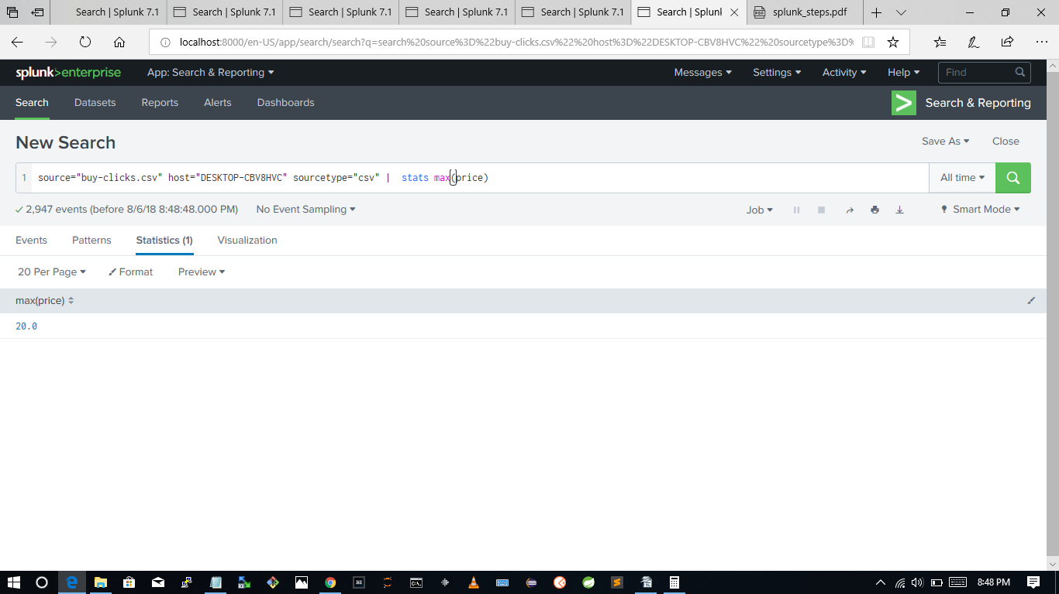

What is the buyId of the item that is purchased the most?
2
3
5
9
